Customer Shopping Behavior Analysis

Project Overview
This project analyzes customer shopping behavior using a transactional dataset of 3,900 purchases. The primary objective is to identify key spending patterns, understand demographic influences on revenue, and evaluate the impact of loyalty programs (subscriptions) and discounts. The insights derived aim to provide actionable data-driven recommendations for marketing and inventory optimization.

Dataset Summary
The dataset provides a granular look at retail transactions with the following characteristics:
- Total Records: 3,900 entries.
- Key Features:
  - Demographics: Age, Gender, Location, and Subscription Status.
  - Transaction Details: Item Purchased, Category (Clothing, Accessories, Footwear, Outerwear), Purchase Amount (USD), and Season.
  - Behavioral Data: Review Rating, Shipping Type, Discount/Promo Code usage, and Previous Purchases.
- Data Quality: The raw data contained 37 missing values in the Review Rating column, which were addressed during the cleaning phase.

Data Preparation & Cleaning
Using the pandas library, the data underwent a rigorous cleaning and transformation process:

Handled missing values and standardized column names for easier SQL integration
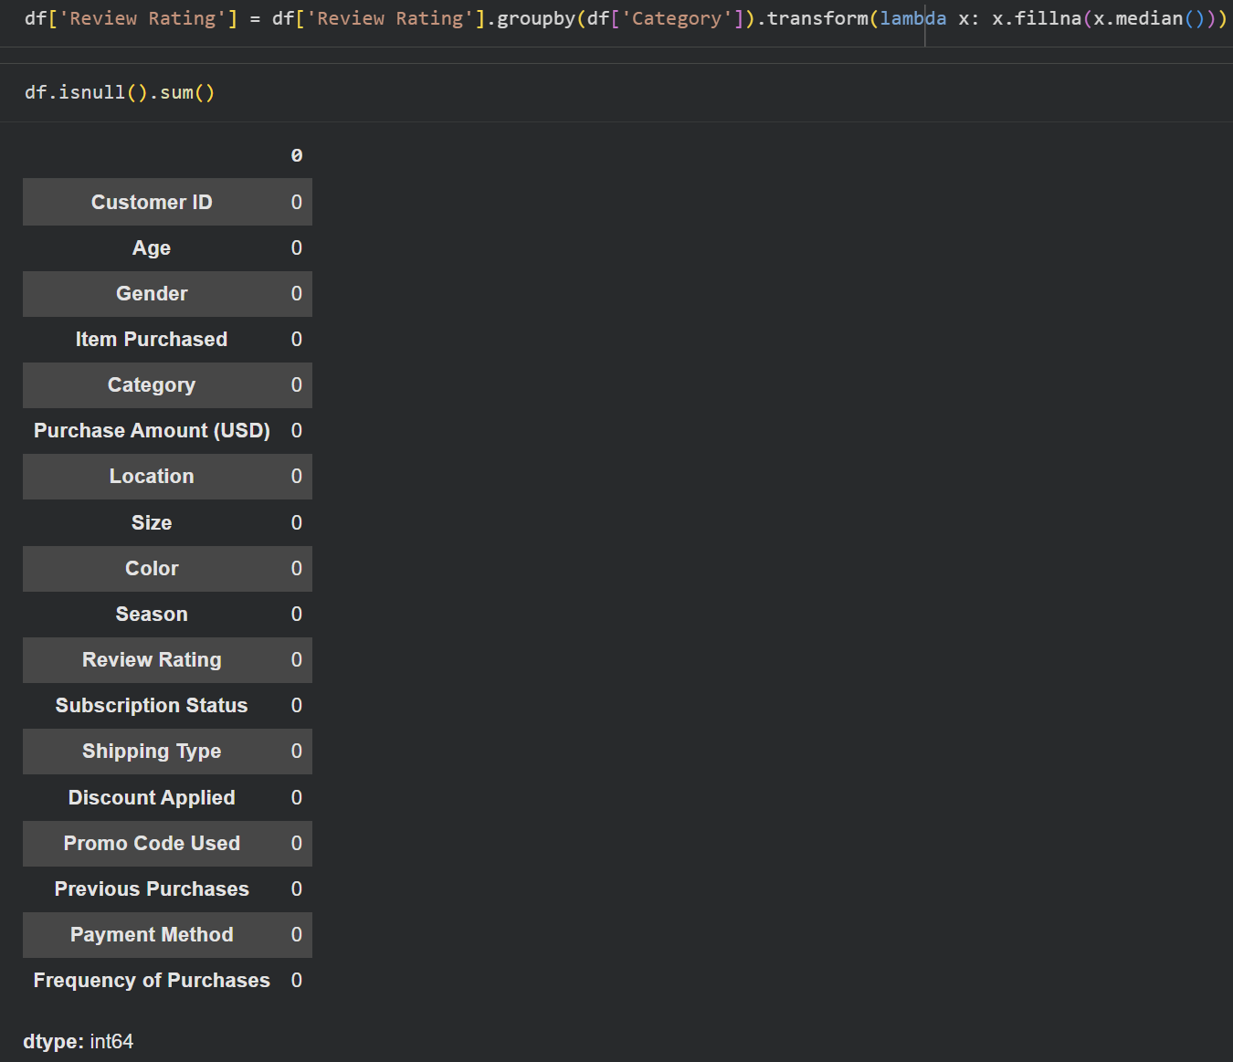
Age Segmentation: Created an age_group column to categorize customers into Young Adult, Adult, Middle-aged, and Senior.
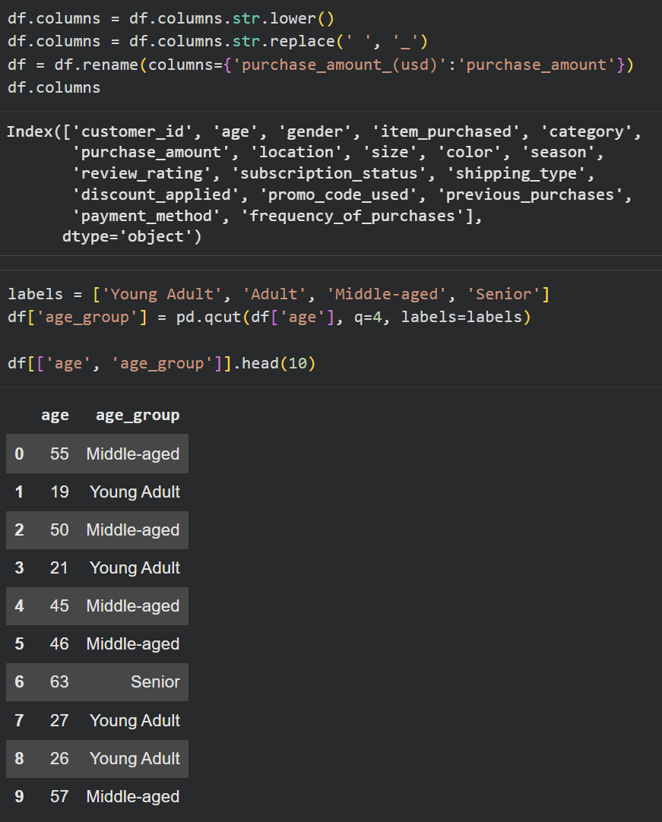
Frequency Mapping: Converted categorical frequency_of_purchases into a numerical purchase_frequency_days to calculate engagement cycles.
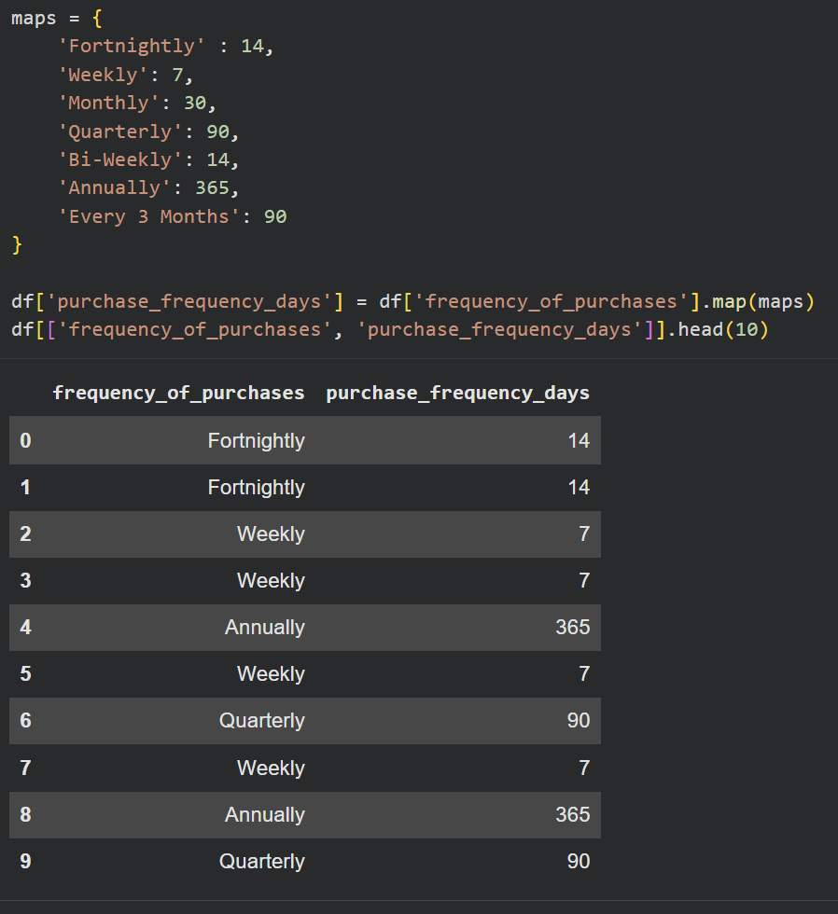

Exploratory Data Analysis
Key business questions were answered using SQL queries to extract deep-level insights:
Total Revenue generated male vs female customers
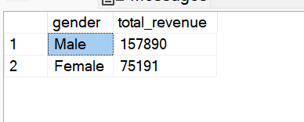
Customers used a discount but still spent more than the average purchase amount
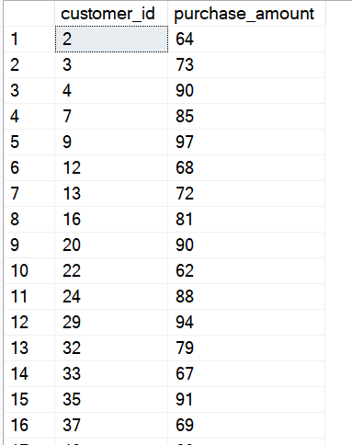
Top 5 products with the highest average review rating
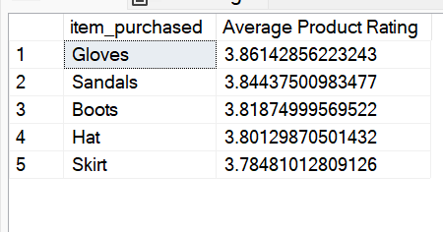
Comparison of average Purchase Amount between Standard and Express Shipping
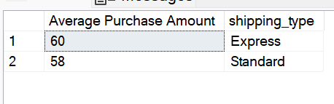
Compare average spend and total revenue between subscribers and non-subscribers
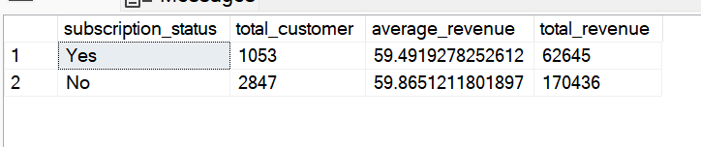
5 products have the highest percentage of purchases with discounts applied
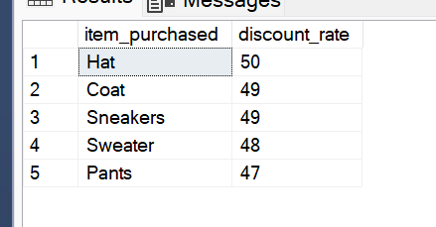
Segmentation of new, returning, and loyal customer
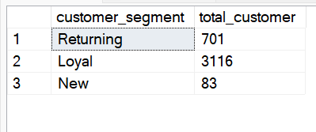
Top 3 most purchased products within each category
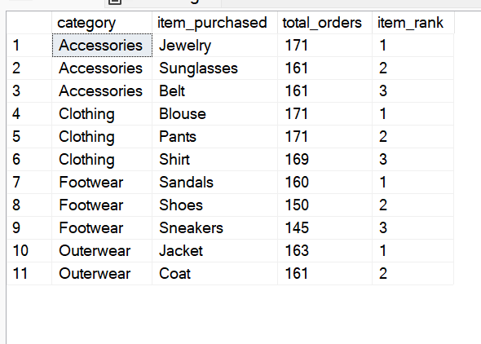
cutomers who are repeat buyers also likely to subsribe
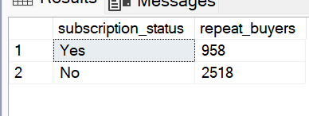
Revenue contribution of each age group
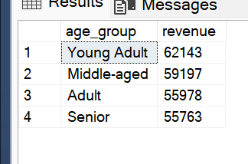

Visualizations
The analysis culminated in an interactive dashboard (Customer Behaviour Dashboard.pbix) featuring:
- Executive KPIs: Total Revenue, Average Purchase Amount ($59.76), and Average Review Rating (3.75).
- Revenue by Age Group: Identified Young Adults as the top contributors with $62,143 in total revenue.
- Category Analysis: Visualized sales distribution showing Clothing and Accessories as the dominant categories.
- Subscription Breakdown: A donut chart highlighting that 27% of the customer base are active subscribers.
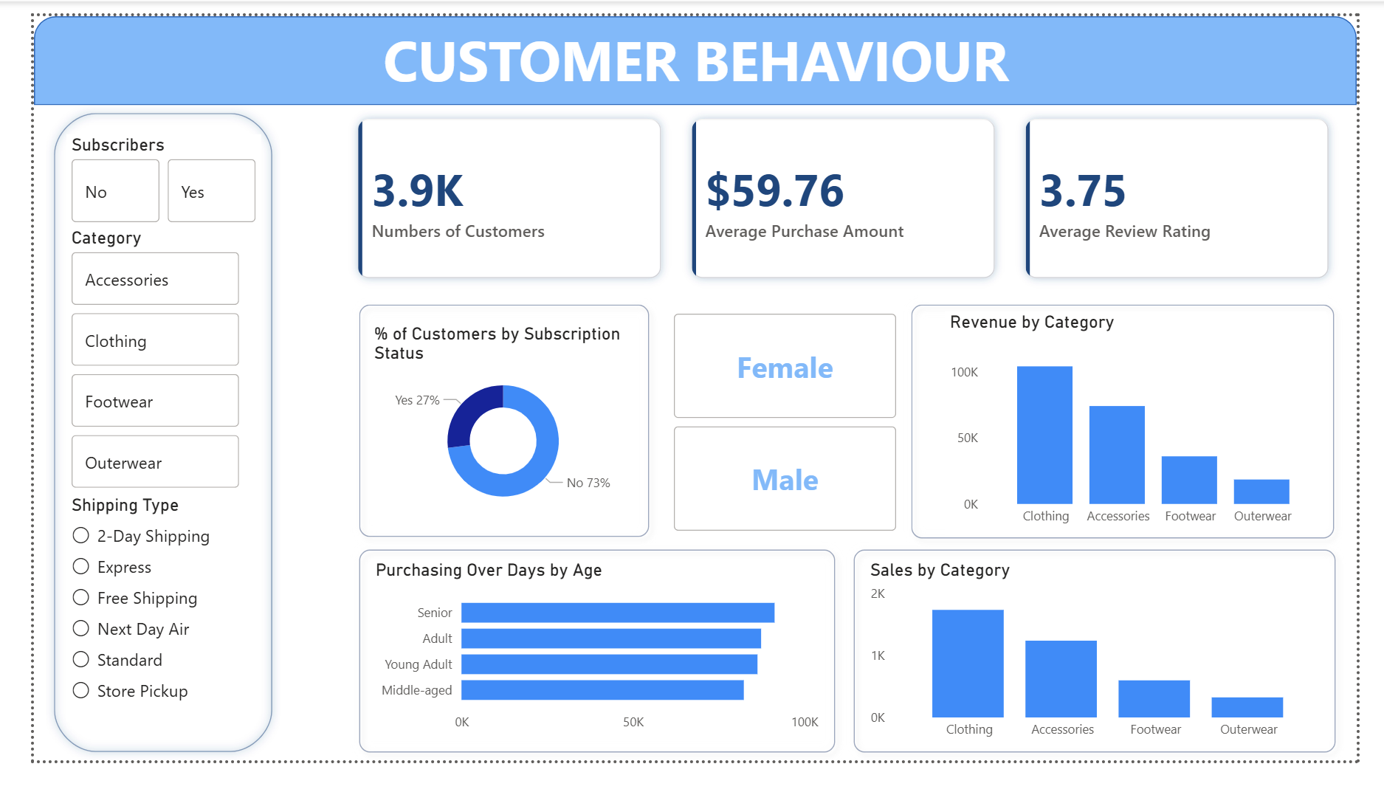
Business Recommendations
Based on the findings, the following strategies are recommended:
- Optimize Subscription Conversion: Since subscribers represent only 27% of the base, implement "Member-Only" discounts to convert the 73% non-subscribers.
- Targeted Marketing for Young Adults: Increase digital ad spend targeting the Young Adult demographic, as they are the highest revenue-generating group.
- Inventory Planning: Align stock levels for Clothing and Accessories categories with seasonal trends (Spring and Fall peaks) identified in the seasonal analysis.
- Loyalty Retention: Introduce a tiered rewards system for the "Returning" segment to accelerate their transition into "Loyal" customers.

